Meeting to run through FOV and Swath Width Requirements

Notes:

Questions/Concerns:

1. In referencing the FOV and Swath Width calculations you provided, how did you determine that 65 degrees, and 0.2 are a desirable FOV and swath width respectively for our mission? I was not able to directly follow your calculations, and performed some research to determine if there are industry-standard methods for evaluating FOV and swath width requirements, and was not able to identify any concrete methods. I ended up using a method documented at the following webpage:

<https://www.jvsg.com/cctv-field-of-view-calculation/>

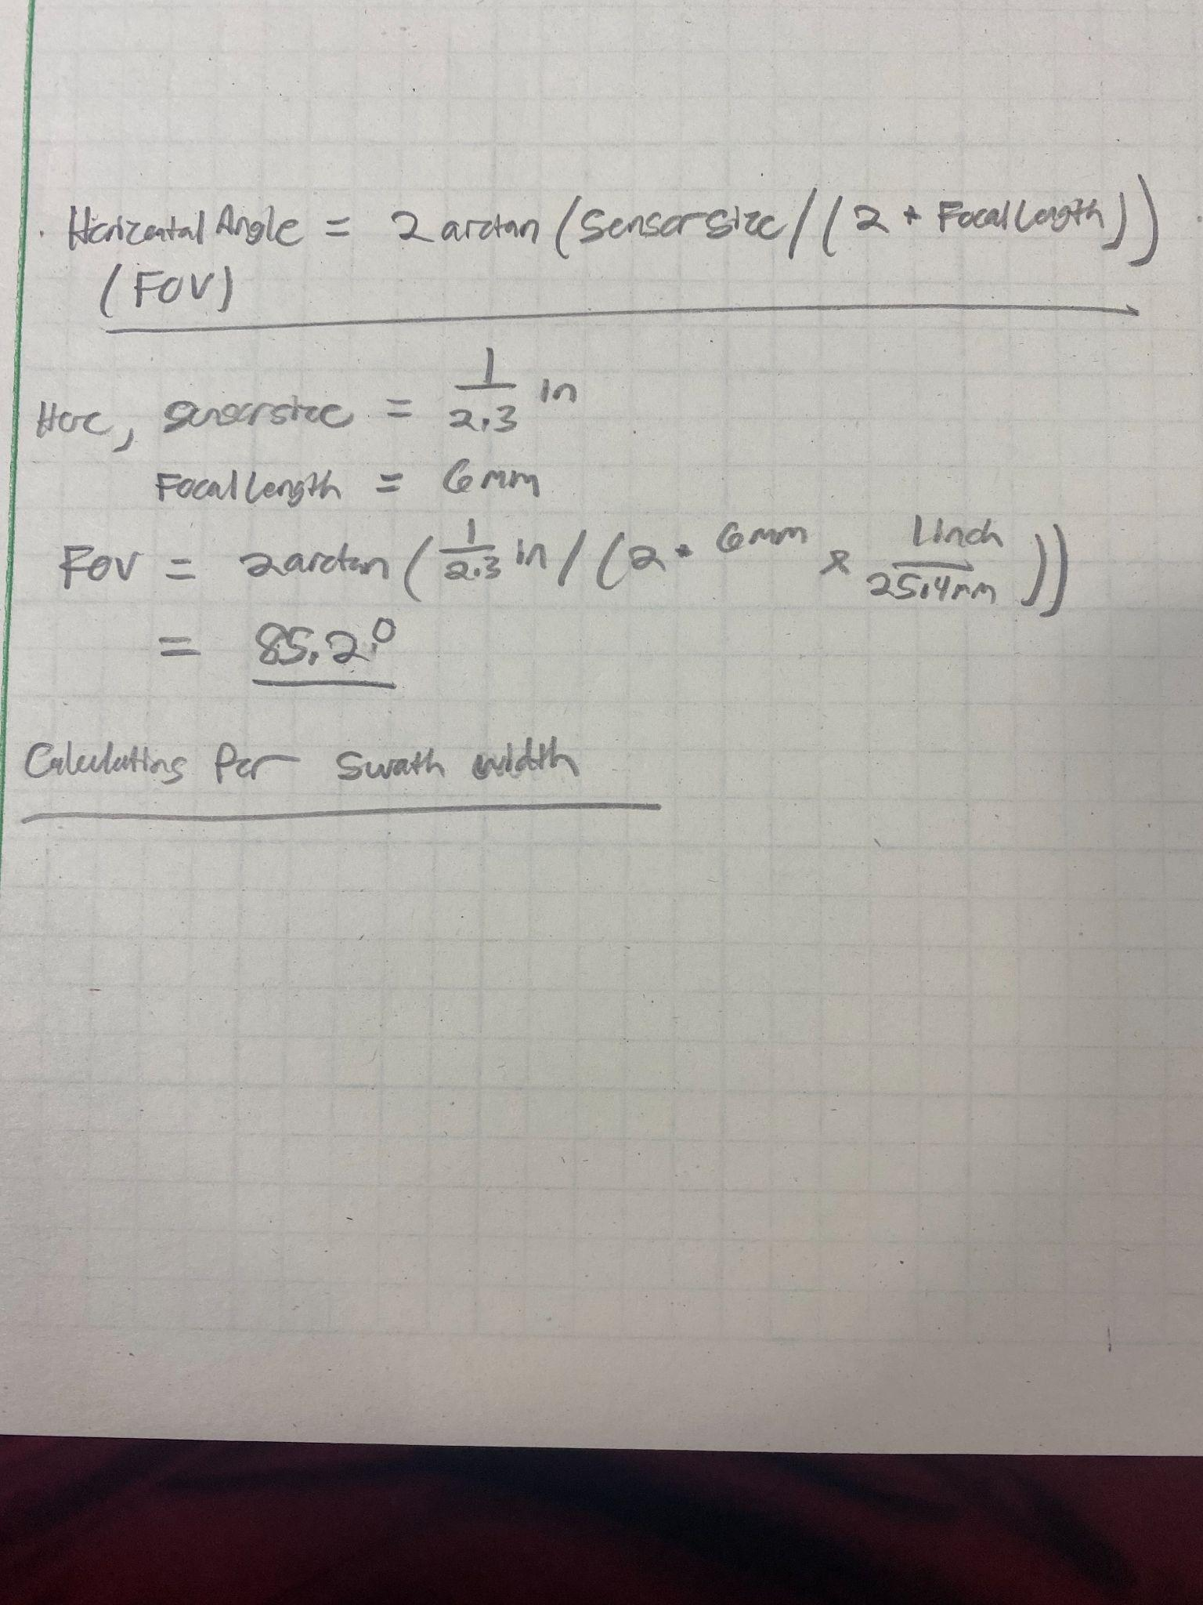

A:

1. What is the estimated delivery time on the co-processor and camera? At some point we would like to take a quadcopter out to the mission site and collect some imagery to train

A: The estimated delivery time is pending.